From the Editor . . .
Up and coming events . . .

September
Saturday 16th Stableford – 1st Round Spring Cup
Wednesday 20th Women - She Oak Trophy - v Tailem Bend & Strathalbyn
Thursday 21st Mid-Week Comp - Stableford
Saturday 23rd Par Bisque – Peak Fresh Trophy
Monday 25th Greens Cored (Subject to change)
Wednesday 27th Women – 4BBB Stableford
Thursday 28th Midweek Comp – Stableford
Saturday 30th Pinehurst – AFL Grand Final Day
Closing date for Committee Nominations 5pm
October
Monday 2nd Labor Day- Stableford - Rnd 4 Public Holiday Trophy
Wednesday 4th Women – Stableford
Twilight - Stableford - 9 holes First week (Subject to change)
Thursday 5th Midweek Comp – Stableford
Saturday 7th Stableford – 2nd Rnd Spring Cup
Wednesday 11th Women Stableford - Last day of qualification for Winter Competitions Twilight Comp – Stableford - 9 holes
Thursday 12th Midweek Comp – Stroke
Saturday 14th Stableford – 3rd Rnd Spring Cup
Wednesday 18th Women – Ambrose – Trophy Presentation –
First day of qualification for Summer Competitions.
Twilight Comp – Stableford - 9 holes
Thursday 19th Mid-Week Comp - Stableford
Saturday 21st Stroke - Monthly Medal, Putting Comp & Eclectic
1st Rnd Qualification Club Championship
1st Rnd Senior Cup,
1st Rnd Junior Championship
Wednesday 25th Women – 3BBB – Stableford in conjunction
Women’s AGM 1.30pm tbc
Twilight Comp – Stableford - 9 holes
Thursday 26th Midweek Comp – Stableford
Friday 27th Echunga Golf Club AGM 7:30pm
Saturday 28th Stroke – Medal of Medals, Putting Comp. & Eclectic
2nd Rnd Club Championship Qualifying
2nd Rnd Senior Cup
2nd Rnd Junior Championship
November
Wednesday 1st Women – Stroke 1st Rnd Club Championship Qualifying Twilight Comp – Stableford - 9 holes

Hi Fellow Golfers! Unfortunately the weather hasn’t been all that kind over August, but it seems to be improving and we should be back in great numbers on the course very soon.
Congratulations to our women who have competed in several competitions, especially Sue Telfer on her win at the Southern Golf Group Championships at Mt Compass.
I heard a rumor that Peter Anderson doesn’t feed his cattle, so they had to find some greener grass on the golf course! Well done to those who assisted in the repair work.
One golfer even made the comment several days later, “Lucky they didn’t get on the greens”
If you have any news items, stories, achievements etc. please drop them in the putter box on the bar or e-mail me at randryeates@gmail.com.

Until next month, good golfing.

Annual General Meeting
7:30pm Friday 27th October 2017

Nominations for Committee Positions
close Saturday 30th September
at 5:00pm

Nominations required for the Positions of
Vice President
Vice Captain
Treasurer
2 x Committee Persons
Each position is for a 2 year term.
Competition Results

Thursday 10th August
Stableford Men 23 Players DSR 73
Women 2 Players DSR 73

G Foster 37
B Guy 36
I Langusch 33
P Coldrey 32
G Vivian 28
J Goff 28

POG B Guy 20
*****************************************
Saturday 12th August
Stableford Men 84 Players DSR 71
Women 1 Players DSR 72

A Grade B Grade
J Oliver 37 A Pietsch 39
M Haslett 37 N Sylvia 36
B Slack 36 B Hodgkison 36
B Guy 35 R Hughes 35
J Chapman 34 B Kidd 35
J Haslett 32 P Johnson 34

C Grade D Grade
N Jordan 35 S Grivell 41
J David-Smith 34 G Milne 35
P Allen 31 R Gerlach 34
S Wilson 31 S Taylor-Hull 33
P Downs 31

NTP 2nd J Haslett
NTP 7th R Hughes
NTP 10th B Smith
NTP 18th P Anderson

NTP in 2 (11th)
A-B B Guy
C-D S Crump
*****************************************
Saturday 26th August
Par Men 43 Players DSR 68
Women - Players DSR --

Division 1 Division 2
B Hodgkison +4 G Milne +2
P Head +3 T Carter +1
J Lawson +2 M Quigley Sq
C McLatchie +1 A Lyon Sq
L Thomas +1 J Goff -2
R Eibisch +1 S Taylor-Hull -2

NTP 7th A Lyon
NTP 18th B Hodgkison
Thursday 31th August
Stableford Men 18 Players DSR 71
Women - Players DSR --

A Bailey 34
B Walter 33
H Hodgkison 33
K Hampton 33
J Goff 30
G Foster 30

NTP 2nd B Guy

POG H Hodgkison 19
B Walter 19
*****************************************
Saturday 2nd September
Stroke Men 72 Players DSR 72
Women - Players DSR ---

A Grade B Grade
B Guy 72 B Hodgkison 70
V Smith 73 B Rogers 72
I Bonython 73 K Hampton 75
S Nailer 75 J Reuter 75
L Thomas 75 A Pietsch 77
H Griffin 75

C Grade D Grade
D Wilson 74 J Goff 71
A Bailey 75 K Gerke 72
C Wenham 76 M Jordan 75
I Langusch 76 S Crump 76
J David-Smith 77 J Hogarth 76
A Horsfall 77

NTP 2nd K Gerke
NTP 7th K Fairchild
NTP 10th G Day
NTP 18th V Smith

NTP in 2 (11th)
A-B R Mills
C-D R Grinter

Monthly Medal
A Grade B Guy 72
B Grade B Hodgkison 85
C Grade A Bailey 95
D Grade K Gerke 97

Putting Comp
A Grade B Guy 24
B Grade K Hampton 28
C Grade I Langusch 29
D Grade J Goff 27
*****************************************

Nearest the Pin:
(Extra sponsors’ vouchers)
2nd Hills Hire $50.00 Voucher

11th $20.00 Meal Voucher Hahndorf Old Mill

*****************************************
Legacy Day at Glenelg

On May 27th , we held our Legacy Day.
The best two Stableford scores across all grades qualify for the Annual Legacy Golf Day.
Anthony Pouw-Bray and Peter Downs were the representatives for Echunga at this event held this year at the Glenelg Golf Club.
They did the club proud, with their 31 and 35 Stableford points respectfully.
Well done to you both!

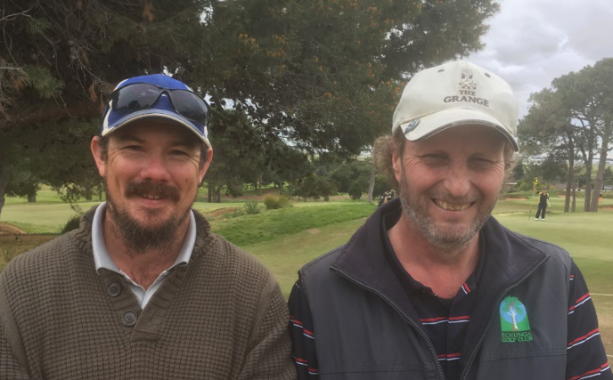

(L to R) Anthony Pouw-Bray and Peter Downs

Carts on course
Unfortunately due to the high rainfall and nature of the course, there are times through the winter months where the club is forced to ban the usage of ride on carts, in order to protect the course. This decision is not taken lightly and is done with the condition of the course as the main priority.
The latest detail on if carts are currently allowed on the course can be found on our web site.
This information will always be current and will be updated by 5:00 pm anytime a change is made.


Junior Clinics

Hi all. We have had to change the September clinic to the 17th due to the wet weather on the 10th.
Also remember to keep an eye on the Echunga website homepage and please leave a contact number when registering, so we can contact you if we need to cancel/change the clinic due to wet weather.

Thanks to all who help out with junior events and clinics.
2pm - advanced group - followed by on-course play

3pm (40mins) - beginners

Sausage sizzle and drink after session
Second Sunday of the month

September 17th
October 8th
November 12th
December 10th - Family Ambrose day

Esther and Jamie Burt
Junior Co-Ordinators, Echunga Golf Club
0424 478 960 Esther
0418 855 831 Jamie

This Month’s Riddle

“Many have heard me, but nobody has seen me, and I will not speak back until spoken to.”
“What am I?”

Answer next month

Last Month’s Riddle
“The more there is, the less you see.”
What am I?

ANSWER: A couple acceptable answers for this one! Darkness or Fog.


Women’s Report
Wednesday 9th August @ Murray Bridge
Stroke - Monthly Medal

M Semmelmann 74/117
J Petherick 80/118
E Burt 83/108
*****************************************Wednesday 16th August @ Murray Bridge
Stableford

J Coleman 26
S Telfer 26
C Carter 25
*****************************************
Wednesday 23rd August @ Murray Bridge
Stroke

J Coleman 69
M Semmelmann 72
*****************************************
Out and About
Mannum Open Day 4th August
Janeen, Sue Telfer, Christine Fensom and Carol Hassan played the Mannum Ladies’ Open Day. There were 26 clubs represented, including Janeen’s friend from Narrandera. It was a full field, the first they had ever had for their Open Day. Although it was crowded on the 9 hole course there were only a few delays on the par 3s, but there we were offered port and a chance to bet on yourself to make the green.
Although there was no rain it was very windy which made for difficult playing conditions resulting in low scores for the day. The overall winner was a local lady, Mary, with 31 pts. Winner A grade 28pts (McLaren Vale), B grade 26pts (Mannum), and C grade winner 26pts was Echunga’s Carol Hassan.
There were longest drives, NTP and nearest to Shaun the Sheep, but none of us won any of these, nor did we take home any raffle prizes, so well done to Carol.
Of course we had the usual delicious lunch, especially the home made cakes, cream puffs and scones!

Oakbank Open Day 25th August
Echunga was again well represented at the Oakbank Open Day. The rain decided to go play somewhere else and the sun shone intermittently.
The course was in excellent condition given the winter we have had, and the soup and nibbles (and port) every time we passed the clubhouse were very welcome. Starting on the 4th of a 9 hole golf course gave us plenty of opportunity to savour the treats.
Our Super Seniors Leonore Steer and Minnie Semmelmann were just too good for the rest of us and took out the runner up nett trophies on the day.
Minnie is on fire!!

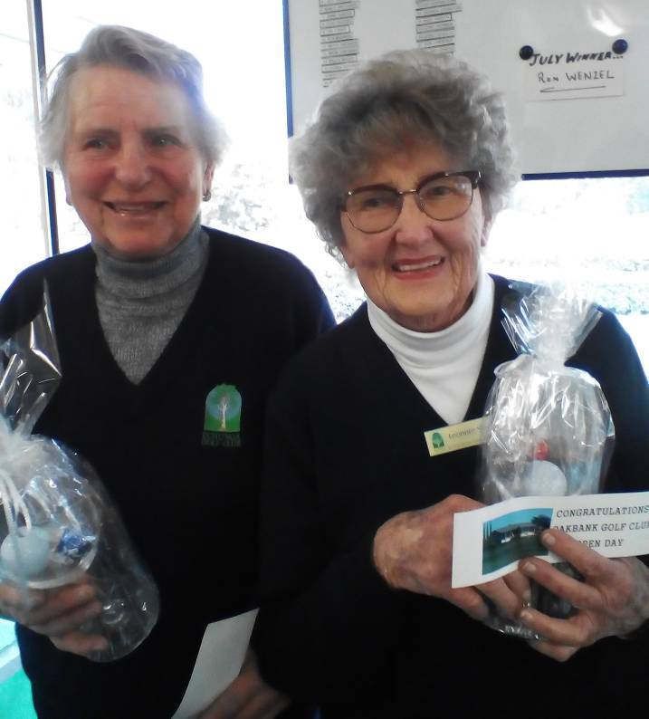

The very generous raffle prizes remained untouched by Echungan hands. It was a great day and thanks to the merry band of Oakbank ladies for doing such a terrific job.
While the Wednesday Echunga Ladies haven't been seen around the Echunga traps for a few
weeks we have certainly still been making our presence felt further afield.

Southern Golf Group Closed Championships Pictured (On the left) is Sue Telfer taking out the B Grade gross winning trophy at the recently held Southern Golf Group Closed Championships at Mt Compass.
The wind made it quite difficult for the players to stay upright and once you finally got your ball on the green, it usually despatched it straight back off again. Well done Sue under very trying conditions.

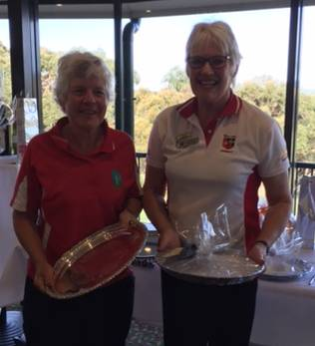

Our other star this month was Wendy Jackson who came third at the McLaren Vale Open Day.

We have been enjoying the hospitality and fine weather at Murray Bridge for a few weeks now but we do look forward to 'coming home' some time very soon.
For those ladies on the sick list we wish you all a speedy recovery and for those travelling to warmer climes, we wish you safe travels.
Bring on Summer!!
Good golfing

Janeen Coleman (Acting Captain)


Important Health Advice
Do you have feelings of inadequacy?
Do you suffer from shyness?
Do you sometimes wish you were more assertive?
Do you feel stressed at times?
If you answered yes to any of these questions, ask your doctor or pharmacist about Cabernet Sauvignon.
Cabernet Sauvignon is the safe, natural way to feel better and more confident about yourself and your actions. It can help ease you out of your shyness and let you tell the world that you're ready and willing to do just about anything.
You will notice the benefits of Cabernet Sauvignon almost immediately and, with a regimen of regular doses, you can overcome any obstacles that prevent you from living the life you want to live.
Shyness and awkwardness will be a thing of the past and you will discover many talents you never knew you had. Stop hiding and start living.
Cabernet Sauvignon may not be right for everyone. Women who are pregnant or nursing should not use it. However, women who wouldn't mind nursing or becoming pregnant are encouraged to try it.
Side effects may include:
Dizziness, nausea, vomiting, incarceration, loss of motor control, loss of clothing, loss of money, loss of virginity, delusions of grandeur, table dancing, headache, dehydration, dry mouth, and a desire to sing Karaoke and play all-night rounds of Strip Poker, Truth Or Dare and Naked Twister.
Warnings:
The consumption of Cabernet Sauvignon may make you think you are whispering when you are not.
The consumption of Cabernet Sauvignon may cause you to tell your friends over and over again that you love them.
The consumption of Cabernet Sauvignon may cause you to think you can sing.
The consumption of Cabernet Sauvignon may create the illusion that you are tougher, smarter, faster and better looking than most people.
Please feel free to share this important information with as many people as you feel may benefit!
Now just imagine what you could achieve with a good Shiraz or Merlot.
LIFE IS A CABERNET, OLD CHUM!

JUNIOR
Coaching Clinics
Sunday 17th September
Sunday 8th October
Sunday 12th November
2:00pm Advanced
3:00pm Beginners
All juniors welcome
No restriction on membership
Bring your children, grandchildren, nieces & nephews, or neighbours.

Flashback!
10 Years ago
Captains Report - Competition Winners

Foursomes Championship –
Saturday 11th August
Champions: Ben Slack and Peter Gilbert – Gross 75
Runners Up: Trevor Huckel and John Norman – Gross 80

David Smart Trophy – Best Nett
Champions: Darren McGlashan and Glynn Palmer – Nett 67
Runners Up: Lloyd Mitchell and Russell Yeates – Nett 67.5

Senior Foursomes
Kevin Wilks and Bob Penny – Nett 72


Monthly Medal – Saturday 19th August
A Grade Suthee Ogg
B Grade Gus Cooper
C Grade Greg Mundy
D Grade Stephen Grivell

Vice Presidents Trophy –
3 Rounds of Stroke Play
Daniel McVitty

Presidents Trophy – 3 Rounds of Stableford
Ben Slack 119pts

Greg Klatt
Captain, Echunga Golf Club

Taken from the September 2007 Putter
5 Years ago
Juniors
How about Billy Cawthorne and Elliot Willgoose who paired up to represent the club along with Matthew Hickman and Randy Jones in the SA Foursomes Championships. They had to play 36 holes off the back markers at Kooyonga.
Billy and Elliot went on to win the best nett score by four shots from the field. A fantastic achievement for the boys and a very proud moment for the club to have the Echunga Club represented by these young men. We wish them both the best as they have both entered in the SA Country Junior Championships to be held at Lake Albert later in the month.
It should be an exciting tussle to see these guys about the course over the next few months. Billy has also been selected to represent Royal Adelaide in their Junior Vardon competition and won the Royal Adelaide Award for Vardon player with the most wins for the season, picked up the Royal Adelaide Junior Championship and lowered his handicap to 5 along the way. Also noticed out on the course this week was Christine Beasley who has progressed in leaps and bounds now representing the state in women's Golf.
Taken from the September 2012 Putter





Making a Stroke
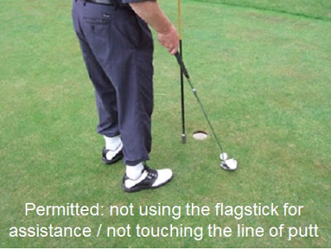
I received a question this week asking whether the shaft or grip of a club can be used to make a stroke. I cannot imagine the circumstance that led to this question being asked, but it has prompted me to list a few points relating to making a stroke at a ball.
• The ball must be fairly struck with the head of the club. Rule 14-1a.
• The head of the club includes the face, back and sides of the club (so, obviously not any part of the shaft or the grip). Note that the clubhead must have only one striking face, except that a putter may have two faces if their characteristics are the same and they are opposite each other. Appendix ll, 1 / 4 / d.
• The ball must not be pushed, scraped or spooned. See this blog for an example of what is not permitted in this respect. Rule 14-1a.
• In making a stroke, the player must not anchor the club, either "directly" or by use of an "anchor point." See this blog for more information on this subject. Rule 14-1b.
• A stroke is the forward movement of the club made with the intention of striking at and moving the ball. So if a player checks their downswing voluntarily before the clubhead reaches the ball, they have not made a stroke. Definition of Stroke.
• A player must not make a stroke while accepting physical assistance (e.g. having an umbrella held over them), or protection from the elements (e.g. aligning their bag to shelter their ball from the wind. Rule 14-2a.
• A player must not use any artificial device or unusual equipment, or use any equipment in an unusual manner that might assist them in making a stroke. Rule 14-3. Note that this includes listening to music or a broadcast, Decision 14-3/17.
• A player must not make a stroke at his ball while it is moving. Rule 14-5. There are 3 exceptions; a) Ball falling off tee, Rule 11-3; b) Striking the ball more than once, Rule 14-4; c) Ball moving in water, Rule 14-6. A player may make a stroke at a ball that oscillates providing it does not move off its spot.
• A player may make a stroke one-handed, e.g. holding the flagstick in the other hand when making a short putt, Decision 17-1/5. (See photo above).
• A player is not necessarily entitled to see their ball when making a stroke. Rule 12-1.
• A player is not penalised for improving their lie or line of play if it occurs while making a stroke, or the backward movement of their club for a stroke, e.g. breaking or moving grasses growing behind their ball when making a stroke from a hazard. Rules 13-2 and 13-4. (Edit 10th February 2017: However, they may not touch the ground in the hazard, water in the water hazard, or move a loose impediment in the hazard with their backswing, Rule 13-4.)
Good golfing,
Welcome to Andrew Turner and Evan Florinis from Commercial SA. They have been sponsoring the 7th Tee block for several years and they are now sponsors of the 12th (Normally the 11th). We thank them for their sponsorship commitment and hope you will use them if you need real estate services.



Echunga Golf Club Inc.

2017 NOMINATIONS

The following positions will be open to Nominations for elections at the 2017 Club AGM at the Club Rooms at 7.30pm on Friday 27th October.

Please ensure that nomination forms have been received by the Secretary by SATURDAY 30th September 2017 at 5pm. Separate nomination forms must be received for each position. (Nominations received after that will not be accepted).

POSITIONS:

Vice President (2 year appointment)

Vice Captain (2 year appointment)

Treasurer (2 year appointment)

Committee Persons 2 positions
(2 year appointments)

IF YOU WISH TO NOMINATE FOR ONE OF THESE POSITIONS PLEASE OBTAIN A NOMINATION FORM FROM THE BAR OR the undersigned.

Bill Walter
Secretary

Club Sponsors

Neutrog Fertilizers- John Paynter, Carol Hasson
Hills Hire– Mike Williams
Chick Transport- John Mooney & Gavin Mooney
JWB Drafting and Design– Jamie & Esther Burt
Solitaire Estate Wines– Paul Freer
Polybags– Ann, Mick & Scott Morton
Peak Fresh Products– Ann, Mick & Scott Morton
Commercial SA- Andrew Turner & Evan Florinis
Janson and Co., Solicitors– Janis Janson
Bowden Print Group– Patrick Buying
The Hahndorf Old Mill Hotel– Craig Fromm
MTA Travel- Christine Fensom
Coopers Rural & Hardware Supplies– Peter & Richard Cooper
Mad Aussie Signs– Andrea & Gibbo Gibson
Echunga Earthmovers– Ryan Bailey
Jumpfirst Jumping Castles– Judy & Mark Hodgy Hodgkison
Victoria Hotel Strathalbyn – Doug Walters
JNH Plumbing and Gas– Jan Harders
Toro Australia- Simon Jones
Coopers Brewery- Jason Ridge
The House of Golf - Mile End- Wayne Tanner

These Companies sponsor our Golf Club. Please repay their generosity by supporting them where possible. If you have a business, or know of a business interested in having their name on a Tee Block Sign please contact the Sponsorship Committee. Any sponsorship would be greatly appreciated and will ultimately help to keep your membership fees down.

5 Fun Facts for your day!
1. Between 1900 and 1920, Tug of War was an Olympic event.
2. Crayola means "oily chalk." The name combines "craie" (French for "chalk") and "ola" (short for "oleaginous," or "oily").
3. The Scots have a word for that panicky hesitation you get when introducing someone whose name you can't remember: tartle.
4. Fredric Baur invented the Pringles can. When he passed away in 2008, his ashes were buried in one.
5. The American Psychiatric Association’s DSM-V handbook classifies caffeine withdrawal as a mental disorder.
CLUBS with which we have
RECIPROCAL AGREEMENTS
South Australia
Barmera Country Club
Blue Lake Golf Club
Kingscote Golf Club
Lameroo Golf Club
Loxton Golf Club
Lucindale Golf Club
Millicent Golf Club
Mount Gambier Golf Club
Murray Bridge Golf Club
Naracoorte Golf Club
Penola Golf Club
Peterborough Golf Club
Port Lincoln Golf Club
Tailem Bend Golf Club
Whyalla Golf Club
Victoria

Bannockburn Golf Club
Hamilton Golf Club
Mildura Golf Club
Murray Downs Golf Club
Mt Beauty Golf Club
Riverside Golf Club Mildura
Sale Golf Club
West Golf Club - Bacchus Marsh

New South Wales

Wentworth Falls Country Club

Northern Territory
Darwin Golf Club

Tasmania

North West Bay Golf Club

All Green Fees will be at ½ the standard Green Fees at each course.
There will also be a maximum of Six Rounds per year at another course.

Any competition fees would be in addition
to the green fees as listed.

If you have details of any other clubs offering
discounted rounds please send me their details.
Russell Yeates ryeates@senet.com.au

September Birthdays
1st Paul Johnson

2nd Bill Walter 30
4th Graham Garvie
Paul Freer
5th Rob Richards 65
6th Dean Carver
Ian Oswald
10th Joe Michalik 70
Rob Hughes
11th Len Goldfinch

Bob Burnett
Paul Le Messurier
12th Bob (Jacko)Jackson
13th Dave Body 65
` Simon Ewart 50
Ben Freer
14th Darryl Curtis
Bret Sando
16th John Hogarth
Evan Florinis

18th Jeff Reuter Andy Amberg
19th Michael Clark Ian Fletcher
Matt Hickman
20th Colin Golding
21st Bruce Watchman `
Trevor Dolman
22nd Garth Dodd 60
Tom Hodgson 20

23rd Ray Bodin Mike Williams
25th Roy Mc Lauchlan 80
26th Paul Vonthien 70
29th Wayne Koop
Kym Erkelenz
30th Ray D'Alessandro

Happy Birthday to all - especially those celebrating a milestone!



Echunga Golf Club Inc.
2015/2016 Management Committee

President Rob Eibisch 0498 193 054
Vice President Ray D’Alessandro 0412 823 029
Secretary Bill Walter 0408 275 159
Treasurer Jarrad David-Smith 0420 983 977
Club Captain Hugh Griffin 0417 547 354
Vice Captain Randy Jones 0406 061 356

Committee
Russell Yeates 0417 834 705
Chris Button 0409 089 203
Peter Anderson 0412 612 611
Suzanne Skibinski 0434 140 674
Sue Maddern 8388 7260

Handicapper

Greg Klatt 8391-1919

Pennant Co-Ordinator

Randy Jones 0406 061 356

Email: egpenants@gmail.com

Membership Manager

Mick Clark 8339-6886

Junior Co-Ordinators
Esther Burt 0424 478 960
Jamie Burt

Bar Manager & Course Bookings
Heather Guy 8388-8038
Email: manager@echungagolf.com.au

Putter Editor
Russell Yeates 8337-4191
Email: randryeates@gmail.com

Sponsorship
Eric March 0418 418 995
Email: sales@ebmpl.com.au
2015/2016 Ladies Committee

President Suzanne Skibinski 0434 140 674
Treasurer Janeen Coleman 8383 7532
Captain Sue Maddern 8388 7260

Committee
Kathy Clarke 0423 981 461
Sheryl Fine 0408 814 271

Next issue deadline:
8th October 2017
We welcome your comments
The success of our newsletter is largely dependant on the contributions of the members.
If you have any snippets of information which you think might be of interest to other members send them straight to the Editor. randryeates@gmail.com

